  - English language- 6th grade
Name :…………………….……….………
Date :……….…………..…………………
WORKSHEET
(Unit 2/ Lesson 1: At the supermarket)

A. Complete the phrases, then match the pictures.

1. We need ________meat in order to make some burgers.
2. Jason has a ________ farm where chicken, turkeys and hens are raised.
3. On a lactose free diet you stop eating ________ products.
4. My favourite ________ is stuffed with cherries.
5. When I got to the butcher’s I always ask for pork ________.
6. Last night I was watching Jamie Oliver making some delicious lamb ________.
7. Doctors say that we should avoid ________ drinks because they contain a lot of sugar.
8. One day I want to be a ________ chef because I am good at baking cakes and sweet pies.

a.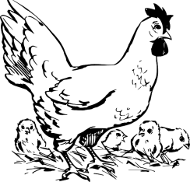 c. 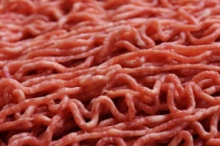 d. 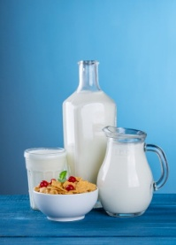 e. 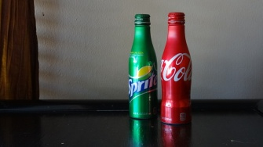

f. g. 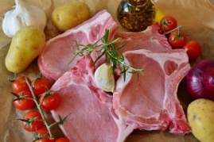 h. 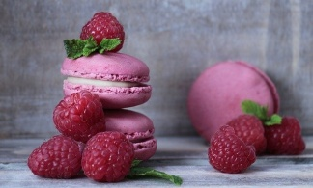 i. 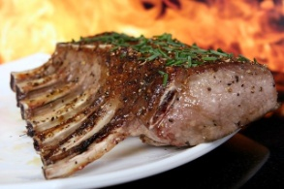

B. Fill in the missing words.

1. a p _ _ _ _ _ of sugar 2. two c _ _ _ of coca cola 3. three c _ _ _ _ _ _ of milk

4. a d _ _ _ _ of eggs 5. two p _ _ _ _ _ _ of biscuits 6. a j_ _ of jam

7. a b _ _ of chocolate 8. a b _ _ of chocolates 9. A t_ _ of tuna

10. a b _ _ _ _ _ of water 11. a b _ _ _ of soup 12. A s _ _ _ _ of pizza

C. Choose the option a or b.

1. When we go the butcher’s…
a. we buy some meat b. we buy vegetables
2. At the bakery
a. we buy poultry and meat b. we buy pastries
3. When we go to the greengrocer’s …
a. we buy some fruit b. we buy books

D. Complete the sentences with some, any, much, many, a lot of.
1. During summer time I like reading ________ books.
2. Would you like ________ coffee, sir?
3. There isn’t ________ milk left in the bottle!
4. How ________ money do you need to get a haircut?
5. ________ people around the world listen to K-POP music.
Key:
Ex.A 1. minced c 2. poultry a 3. dairy d 4. pie f 5. chops 6. Ribs i 7. Soft e 8. Pastry h
Ex.B 1. pound, 2. cans, 3. Cartons, 4. Dozen, 5. Packet 6. Jar, 7. Box 8. Bar 9. Tin 10. Bottle 11. Bowl 12. slice
Ex.C 1. A, 2. B, 3. a
Ex.D 1. a lot of 2. Some 3. any 4. Much 5. A lot of

Graphics from https://pixabay.com

