English language- E’ class
Date:
Lesson Plan
Unit 10, Lesson 2: Tourists love visiting places
Class Time: 3 teaching periods
Teaching Aids: Interactive whiteboard, chart for the game in the classroom, Blu tack or cellotape, A4 sheets of paper
Presentation - New Materials | SB, pp. 126-129  Power Point-Presentation, Unit 10, Lesson 2  http://photodentro.edu.gr/v/item/ds/8521/4811
Consolidation - Application | WB, pp. 61-62
Homework | Worksheet, Unit 10, Lesson 2

Extra games:
You can play these games online:
The Food Pyramid
http://ebooks.edu.gr/modules/ebook/show.php/DSDIM-E103/440/2920,11583/extras/Mystery/U10_L2_Guess_What_The_Food_Pyramid/index.html
Vocabulary quiz
http://photodentro.edu.gr/v/item/ds/8521/4812
Hangman
http://photodentro.edu.gr/v/item/ds/8521/4759
Live a healthy life
http://aesop.iep.edu.gr/node/7049
Build the food pyramid
http://photodentro.edu.gr/aggregator/lo/photodentro-lor-8521-3550

You can play this game in the classroom:
Running Dictation
The students play the game in 3-5 teams (depending on the size of the class – each team should consist of 4-5 players). Make as many photocopies as the teams and paste them on the board. Each team has an A4 sheet of paper. The students have to take turns and come to the board, memorize a sentence from the text about the Parthenon, go back to their seats and write that down on the A4 sheet of paper. The game is played for 5-7 minutes. At the end of the allocated time, sheets are collected and points are awarded. Each team gets 10 for each sentence they have copied. If one sentence is left unfinished, they get as many points as the number of words they have managed to write. One point is detracted for each spelling mistake or omission. When the winning team is announced, it’s a good idea to talk about the text, explain it (with the help of the students) and help them learn more about our important monument.
Instructions: Take turns in your team to come to the board and memorize one sentence from the text that talks about the Parthenon. Then, go back to your desk and write it on your sheet. If you forget something, you can go back to board and read the sentence again. You can do that as many times as you want. When you finish, pass the sheet of paper to a classmate in your team who will continue copying the text. When time is over, your teacher will calculate your score. You will get 10 points for each sentence you copy and 1 point minus for each spelling mistake and omission.
Handout:
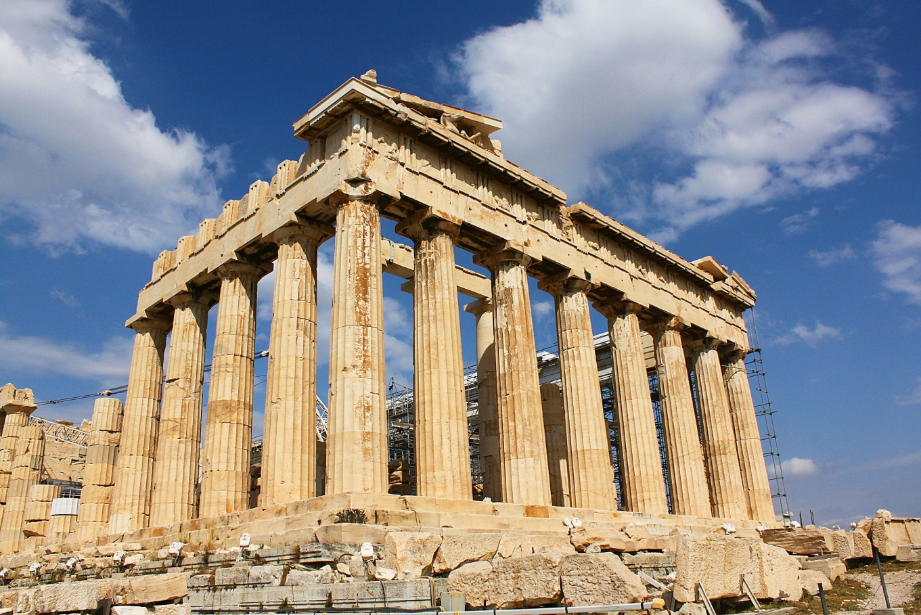The Parthenon, on the Acropolis hill, was built between 447 and 438 B.C., by the architects Iktinos and Kallikrates. The famous sculptor Pheidias, a friend of Pericles, supervised the construction. It is a temple made of white Pentelic marble and it is about 70 metres long, 31 metres wide and 15 metres high. Inside the Parthenon, Pheidias built a 13-metre-high statue of the goddess Athena using gold and ivory. Outside the Parthenon was the peristyle, which surrounded the temple with columns. There were 108 columns outside and inside the Parthenon in total.

Video
Watch these videos, learn about healthy eating and see how Lord Elgin took the Parthenon sculptures.
Healthy eating
https://www.youtube.com/watch?v=O0T3EP4NEpI
Lord Elgin taking the Parthenon sculptures
https://www.youtube.com/watch?v=qV83kJPkn5M

Reader

Read about the Parthenon and how Lord Elgin removed its sculptures
http://2gym-lefkad.lef.sch.gr/wp/wp-content/uploads/2015/09/%CE%A0%CE%91%CE%A1%CE%98%CE%95%CE%9D%CE%A9%CE%9D%CE%91%CE%A3.pdf?4d5f0f

- against: εναντίον
- call upon: κάνω έκκληση, ζητάω βοήθεια
- case: περίπτωση
- chairperson: πρόεδρος
- congratulate (sb on): συγχαίρω (κάποιον για)
- cuisine: κουζίνα (τρόπος μαγειρικής χαρακτηριστικός για μια χώρα)
- debate: διαφωνία, συζήτηση
- dedicated: αφιερωμένος
- during: κατά τη διάρκεια
- especially: ιδιαίτερα, ειδικά
- government: κυβέρνηση
- Her Majesty: Η Μεγαλειότητά της (η βασίλισσα)
- immediately: αμέσως
- impress: εντυπωσιάζω
- in favour of: υπέρ, προς υπεράσπιση
- matter: θέμα
- member of the Parliament: βουλευτής
- negotiation: διαπραγμάτευση
- pasta: ζυμαρικά
- quality: ποιότητα
- recent: πρόσφατος
- speciality: σπεσιαλιτέ μαγειρικής
- success: επιτυχία
- support: υποστηρίζω
- therefore: επομένως
- vote/voter: ψηφοφορία/ψηφοφόρος

