English language- E’ class
Name :…………………….……….………
Date :……….…………..…………………
WORKSHEET
(Unit 10/ Lesson 2: Tourists love visiting places)
A. Follow this link http://ebooks.edu.gr/modules/ebook/show.php/DSDIM-E103/440/2920,11583/ to activity Ⓑ Reading, on p. 126, click on and listen to the listening extract. Then, choose the correct answer to the following questions.

1. “Fifteen-to-one” programme is on … .
A. Channel 1 | B. Channel 3 | C. Channel 4
2. People who watched the programme expressed their opinions … .
A. through telephone | B. on the internet | C. by sending letters
3. Most of the people who voted wanted the marbles … .
A. to stay in the British Museum | B. to go back to Greece | C. to be sold to another country
4. … people still care about the return of the marbles to Greece.
A. Lots of | B. Not many | C. Only 100 members of the British Parliament

A. Follow this link http://ebooks.edu.gr/modules/ebook/show.php/DSDIM-E103/440/2920,11579/ to activity Ⓓ Reading, on p. 116, click on and read and listen to the reading text. Then, find words or phrases in the text which mean the same as the following:

- that happened a short time ago: …………………………
- made specially for: …………………………
- an occasion when people give an opinion: …………………………
- supporting: …………………………
- ask someone to do something: …………………………
- discussion to reach an agreement: …………………………

C. The following arguments are FOR or AGAINST the return of the Parthenon sculptures. Put them in the right category. Write F for FOR or A for AGAINST.

- It’s very expensive to bring the marbles back to Greece. Who will pay for that? ………
- Athens is a polluted city. If the marbles go back, pollution will destroy them. ………
- The marbles are part of the Greek history. ………
- The Acropolis Museum can provide a safe and suitable home for the marbles. ………
- The Sultan’s decision (firman) for Lord Elgin said he could only take “some stones”, not half the Parthenon! ………
- Returning the marbles will help tourism, which is good for the Greek economy. ………
- If the marbles return to Greece, then other countries will ask for their historical treasures back. We can’t let this happen. ………
- When the British Museum tried to clean the marbles, they damaged them. They don’t take good care of the marbles. ………

D. Put the food categories in the food pyramid.

milk and cheese (14%), fruit and vegetables (29%), meat, nuts and eggs (16%), oil and sweets (3%), bread and pasta (38%)
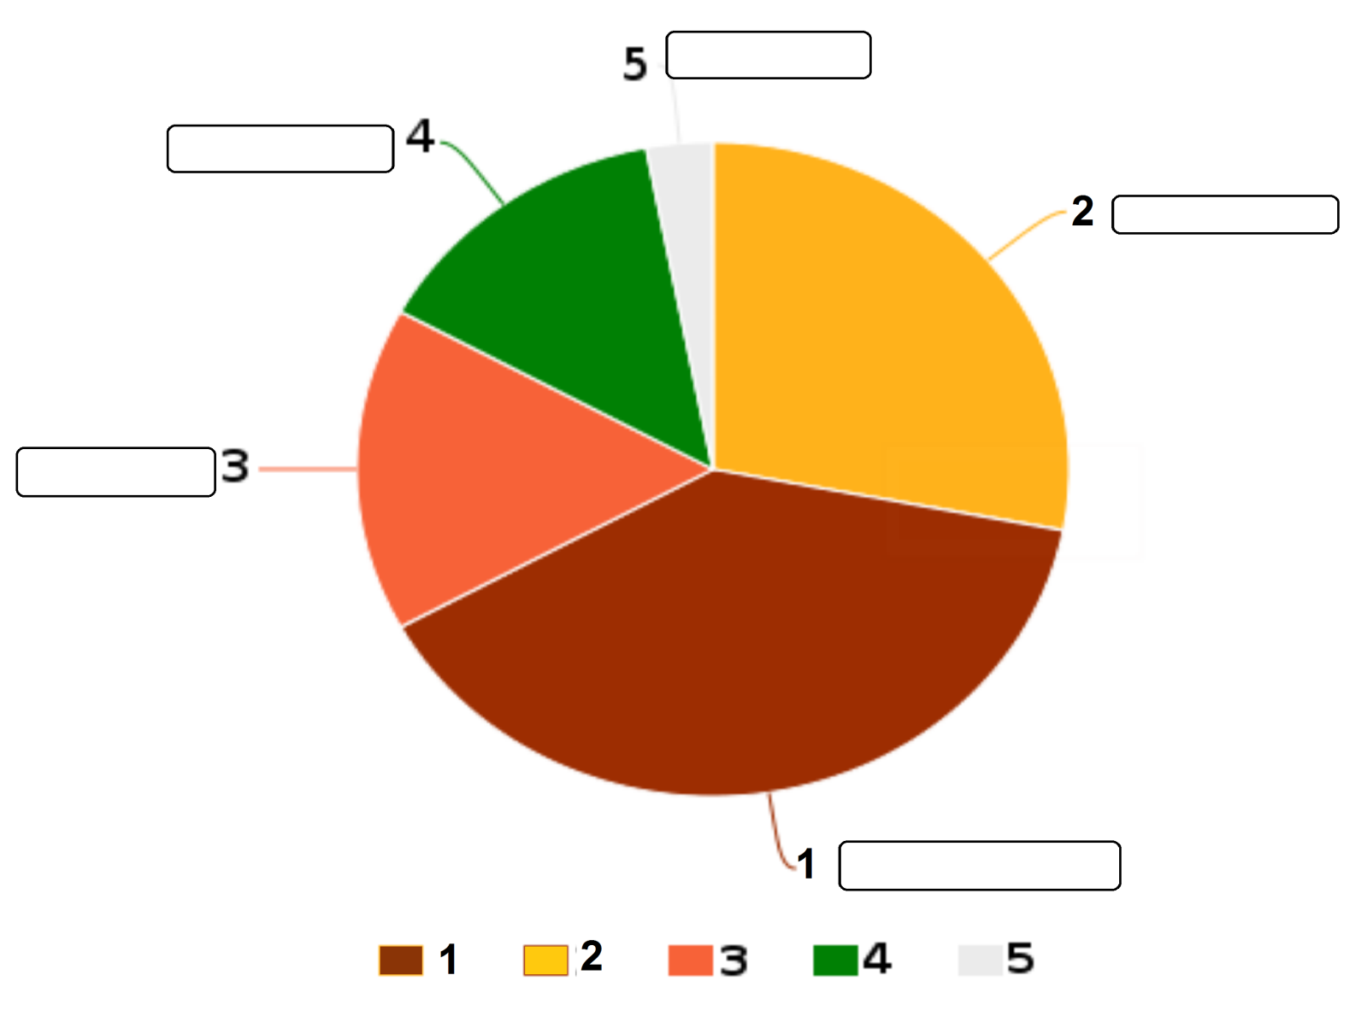

Key to the exercises:
A. 1C, 2A, 3CB, 4B
B. 1-recent, 2-dedicated, 3-vote, 4-in favour of, 5- call upon, 6-negotiations
C. 1A, 2A, 3F, 4F, 5F, 6F, 7A, 8F
D. 1- bread and pasta, 2- fruit and vegetables, 3- meat, nuts and eggs, 4- milk and cheese, 5- oil and sweets

