WORKSHEET 6.3
(Unit 6/ Lesson 3)
Exercise 1
• Complete the blanks with the correct word from the box.
wolf, duck, sheep, wild goat, cow, caretta caretta turtle

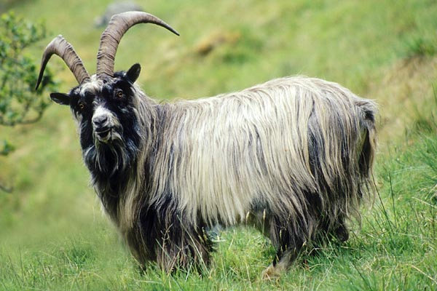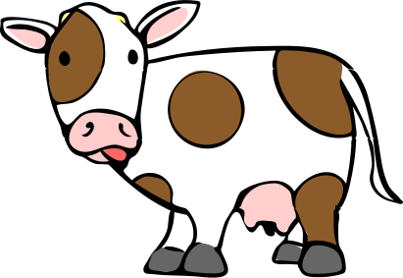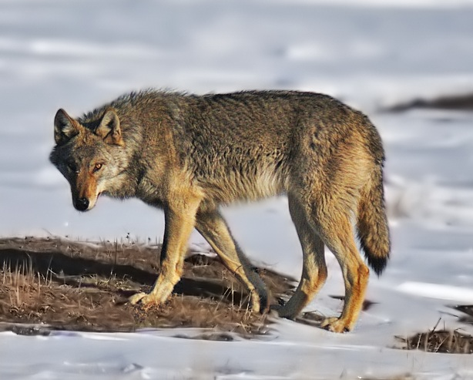
- _____________ 2. ______________ 3. ______________
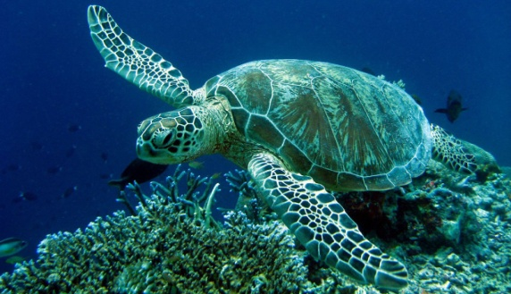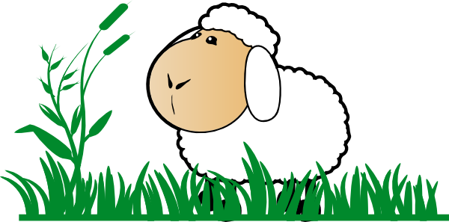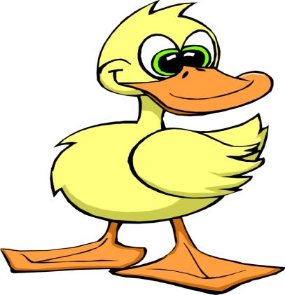
- . ____________ 5 . ______________ 6. _______________
Exercise 2
●Write the words next to the pictures.
1. 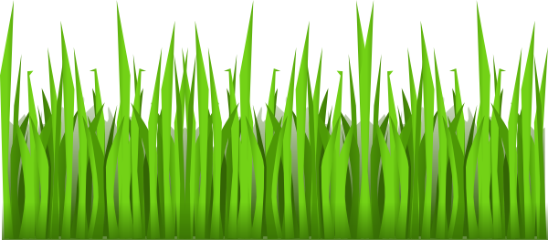 ______________
2. 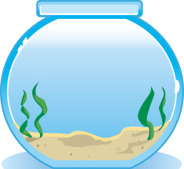 ______________
3. ______________
4. ______________
5. ______________
Exercise 3
● Match the two columns.
- A bird lives a) milk
- A goldfish swims b) in a cage
- A sheep eats c) on trees
- A cow makes d) in a pond
- A duck swims e) grass
- An iguana climbs f) in a bowl
Exercise 4
● Write a paragraph under each table using the information from the boxes.
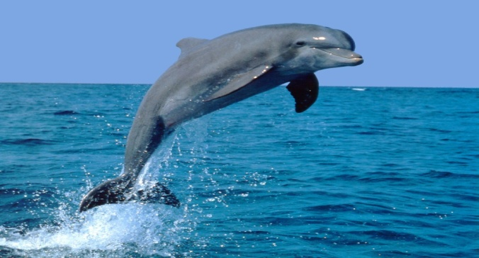 | It lives | It eats | It weighs
Doplhin | In the Mediterranean Sea | Small Fish | One hundred ten kilos
The dolphin lives in ________________________. It eats _________________________ and it weighs _____________________________________________________kilos.
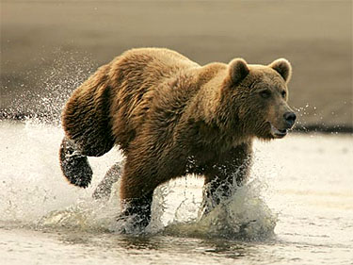 | It lives | It eats | It weighs
Brown Bear | In the mountains of Pindos and Rodopi | Wild goats, grass, roots and fish | Two hundred fifty kilos
The brown bear ___________________________________________________________________________________________________________________________________________________________________________________.

Exercise 5
• Complete the blanks with the correct word from the box. Use the pictures to help you.
horns, poachers, habitat, fur, fishing nets, meat, hunters
______________ 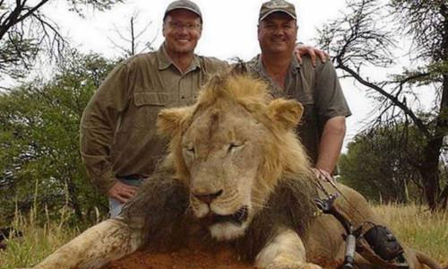 (1) are ______________ (2) who kill
endangered animals to take their ____________ 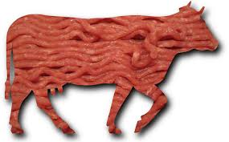(3),
_________ 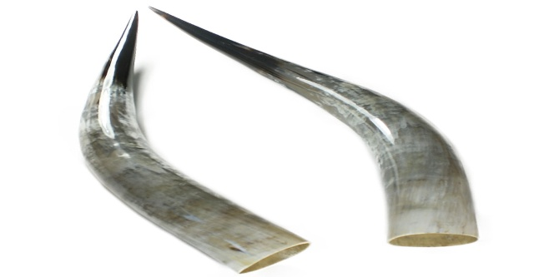(4) and _________ 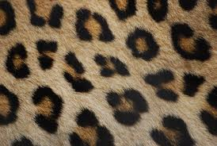(5).

Exercise 6
● Use the pictures to say why some animals are in danger.
Some animals like the ____________ 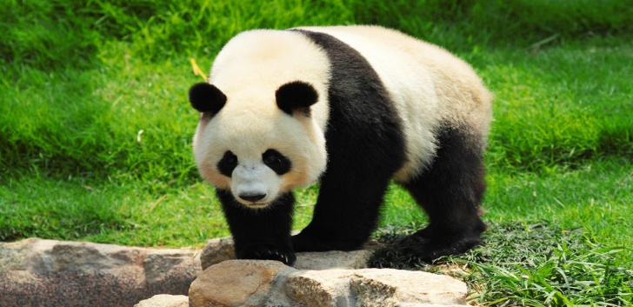(1) or the
_______________ 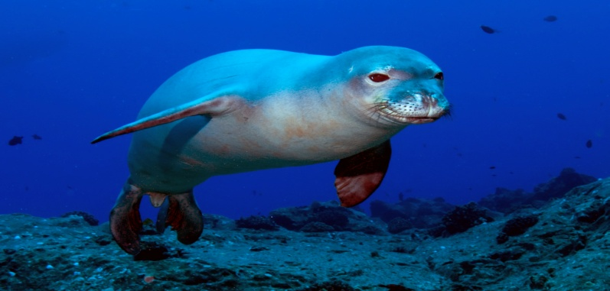 (2) are in great danger. This is true because people want to take their ____________ 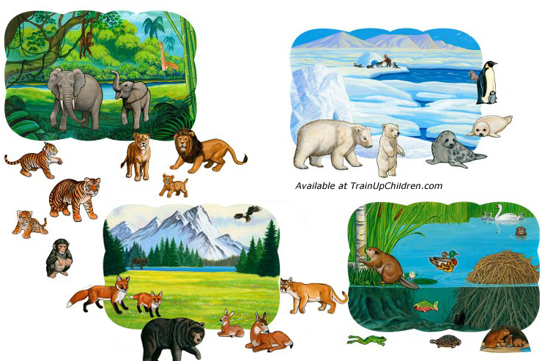(3) or use ____________ 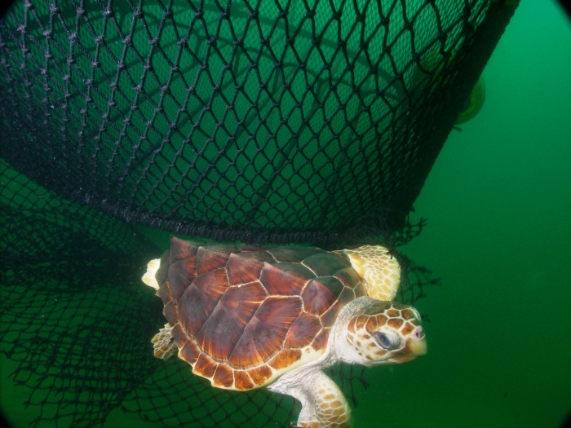 (4) to catch them.
_______________ 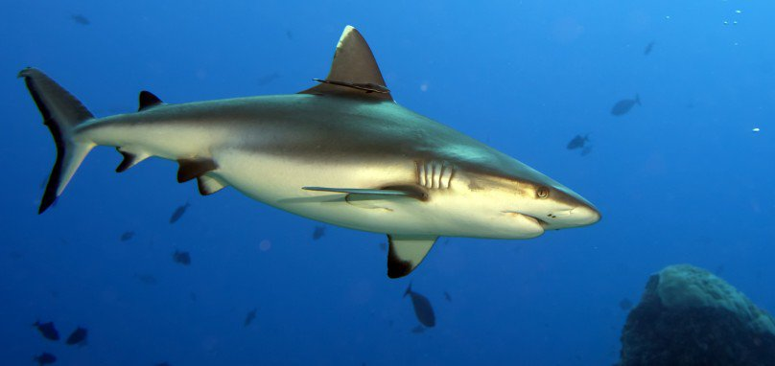 (5) also eat caretta caretta turtles.

Exercise 7
● Choose an endangered animal and write about it. Use all the exercises above to help you. Say:
- its name
- the place it lives
- what it eats
- how many kilos it weighs
- why it is in danger
_______________________________________________________________________________________________________________________________________________________________________________________________________________________________________________________________________________________________________________________________________________________________________.

KEY
Exercise 1
- Wild goat 2. Cow 3. Wolf 4. Caretta caretta turtle
5. Sheep 6. Duck
Exercise 2
- Grass 2. Bowl 3. Cage 4. Pond 5. Milk
Exercise 3
- B 2. F 3. E 4. A 5. D 6. C
Exercise 4
(paragraph 1)
The dolphin lives in the Mediterranean Sea. It eats small fish and it weighs one hundred ten kilos.
(paragraph 2)
The brown bear lives in the mountains of Pindos and Rodopi. It eats wild goats, grass, roots and fish. It weighs two hundred fifty kilos.

Exercise 5
- Poachers 2. Hunters 3. Meat 4. Horns 5. Fur
Exercise 6
- Giant pandas 2. Monachus monachus turtles 3. Habitat
4. Fishing nets 5. Sharks
Exercise 7
(suggested answer)
The brown bear is an endangered animal. It lives in the mountains of Pindos and Rodopi. It eats wild goats, grass, roots and fish. It weighs two hundred fifty kilos and it is in danger because people want to take its fur and its habitat.

